**Insert School Logo**

**Semester One**

**Examination 2020**

**Question/Answer booklet**

**MATHEMATICS**

**APPLICATIONS UNIT 1**

**Section Two:**

**Calculator–assumed**

|  |
| --- |
| Student Name: _____________________________________ |
| Teacher’s Name: _____________________________________ |

**Time allowed for this section**

Reading time before commencing work: ten minutes

Working time for paper: one hundred minutes

**Material required/recommended for this section**

**To be provided by the supervisor**

This Question/Answer booklet

Formula Sheet (retained from Section One)

**To be provided by the candidate**

Standard items: pens (blue/black preferred), pencils (including coloured), sharpener, correction tape/fluid, erasers, ruler, highlighters

Special Items: drawing instruments, templates, notes on two unfolded sheets of A4 paper, and up to three calculators approved for use in the WACE examinations.

**Important note to candidates**

No other items may be taken into the examination room. It is **your** responsibility to ensure that you do not have any unauthorised notes or other items of a non-personal nature in the examination room. If you have any unauthorised material with you, hand it to the supervisor **before** reading any further.

**Structure of this paper**

|  |  |  |  |  |  |
| --- | --- | --- | --- | --- | --- |
|  | Number of questions available | Number of questions to be attempted | Working time (minutes) | Marks available | Percentage of exam |
| Section One  Calculator—free | 7 | 7 | 50 | 50 | 35 |
| **Section Two**  **Calculator—assumed** | **15** | **15** | **100** | **100** | **65** |
|  | | | |  | 100 |

**Instructions to candidates**

1. The rules for the conduct of Western Australian external examinations are detailed in the

*Year 12 Information Handbook 2020.* Sitting this examination implies that you agree to abide by these rules.

2. Answer the questions according to the following instructions.

**Show all your working clearly.** Your working should be in sufficient detail to allow your

answers to be checked readily and for marks to be awarded for reasoning. Incorrect answers given without supporting reasoning cannot be allocated any marks. For any question or part question worth more than two marks, valid working or justification is required to receive full marks. If you repeat an answer to any question, ensure that you cancel the answer you do not wish to have marked.

It is recommended that you **do not use pencil**, except in diagrams.

3. You must be careful to confine your responses to the specific questions asked and to follow any instructions that are specific to a particular question.

4. Spare pages are included at the end of this booklet. They can be used for planning your responses and/or as additional space if required to continue an answer.

* Planning: If you use the spare pages for planning, indicate this clearly at the top of the

page.

* Continuing an answer: If you need to use the space to continue an answer, indicate in the

original answer space where the answer is continued, i.e. give the page number. Fill in the

number of the question that you are continuing to answer at the top of the page.

5. The Formula Sheet is **not** handed in with your Question/Answer Booklet.

# Section Two: Calculator–assumed 65% (100 marks)

This section has **fifteen (15)** questions. Attempt **all** questions. Write your answers in the spaces

provided.

Spare pages are included at the end of this booklet. They can be used for planning your responses

and/or as additional space if required to continue an answer.

* Planning: If you use the spare pages for planning, indicate this clearly at the top of the page.
* Continuing an answer: If you need to use the space to continue an answer, indicate in the original answer space where the answer is continued, i.e. give the page number. Fill in the number of the question(s) that you are continuing to answer at the top of the page.

Working time: 100 minutes

**Question 8 (4 marks)**

(a) On an architect’s plans, a building was drawn to a height of 6.7cm.

The scale on the plan was written as 1 : 1200.

Determine the actual height of the building in metres to one decimal place. (2 marks)

(b) The drawing below is an enlargement of a shape. It has been drawn to a

scale of 4 : 1. Draw on the grid below the actual shape. (2 marks)

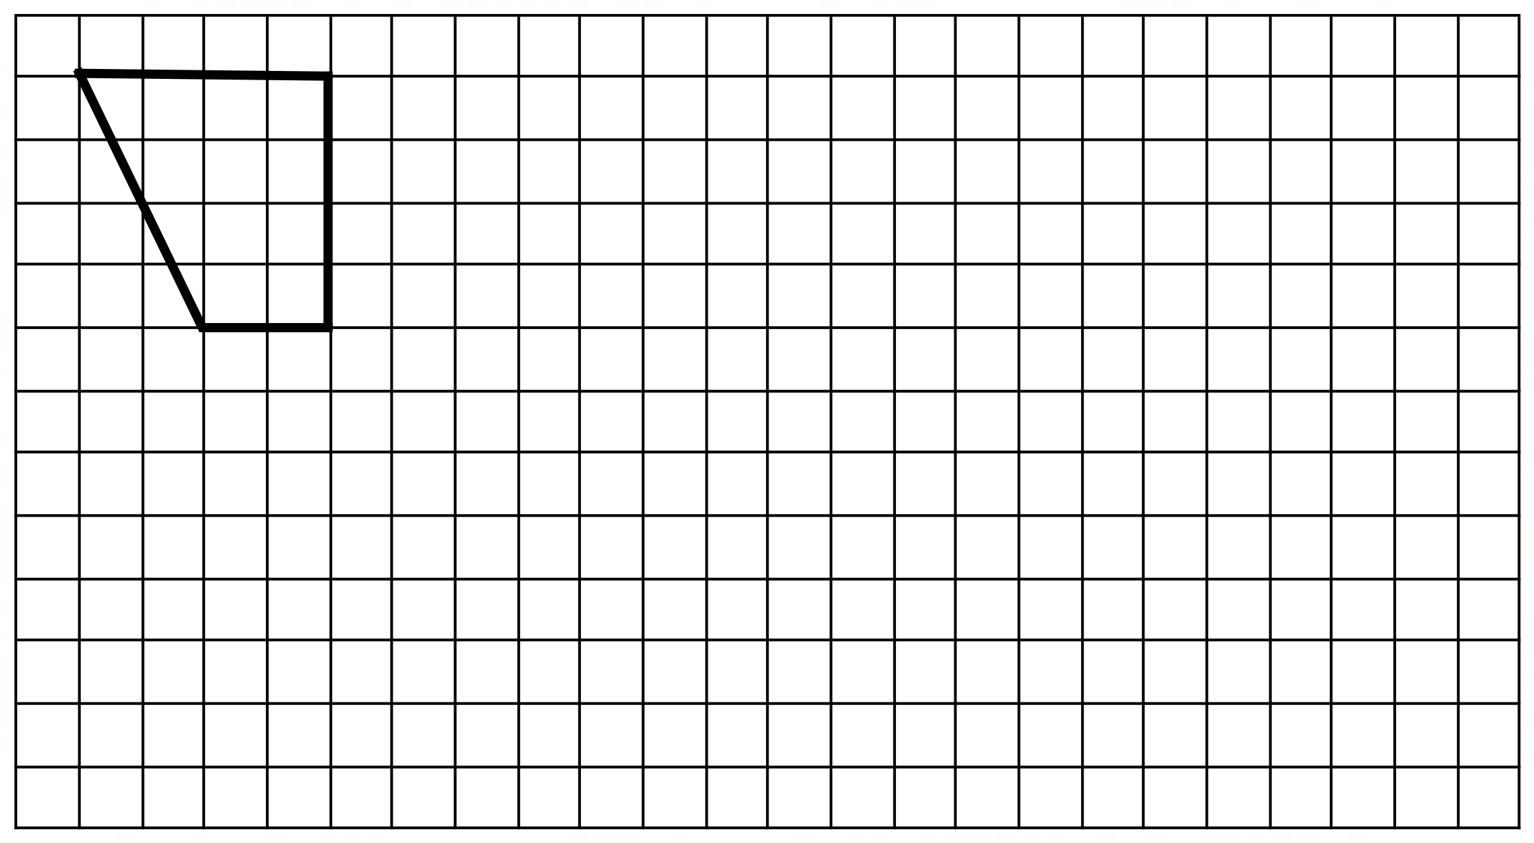

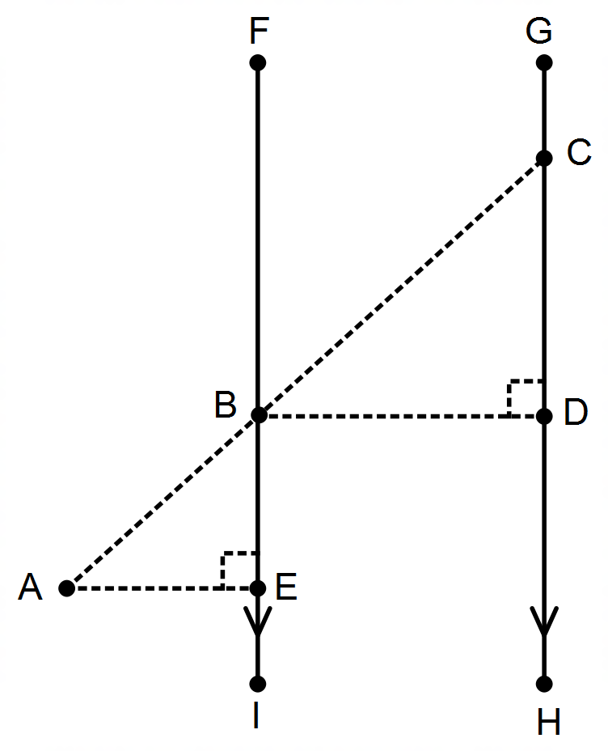**Question 9 (6 marks)**

(a) For the following diagram:

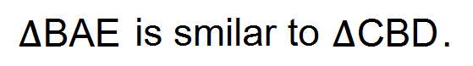

FI and GH are parallel lines.

CD measures 68.5cm.

BE measures 13.7cm.

AE measures 7.25cm.

Determine the measurement of BD. (2 marks)

(b) A steel frame for a patio is to be built as shown in the diagram below. Determine

the total amount of steel, to the nearest metre, needed to make the frame. (4 marks)

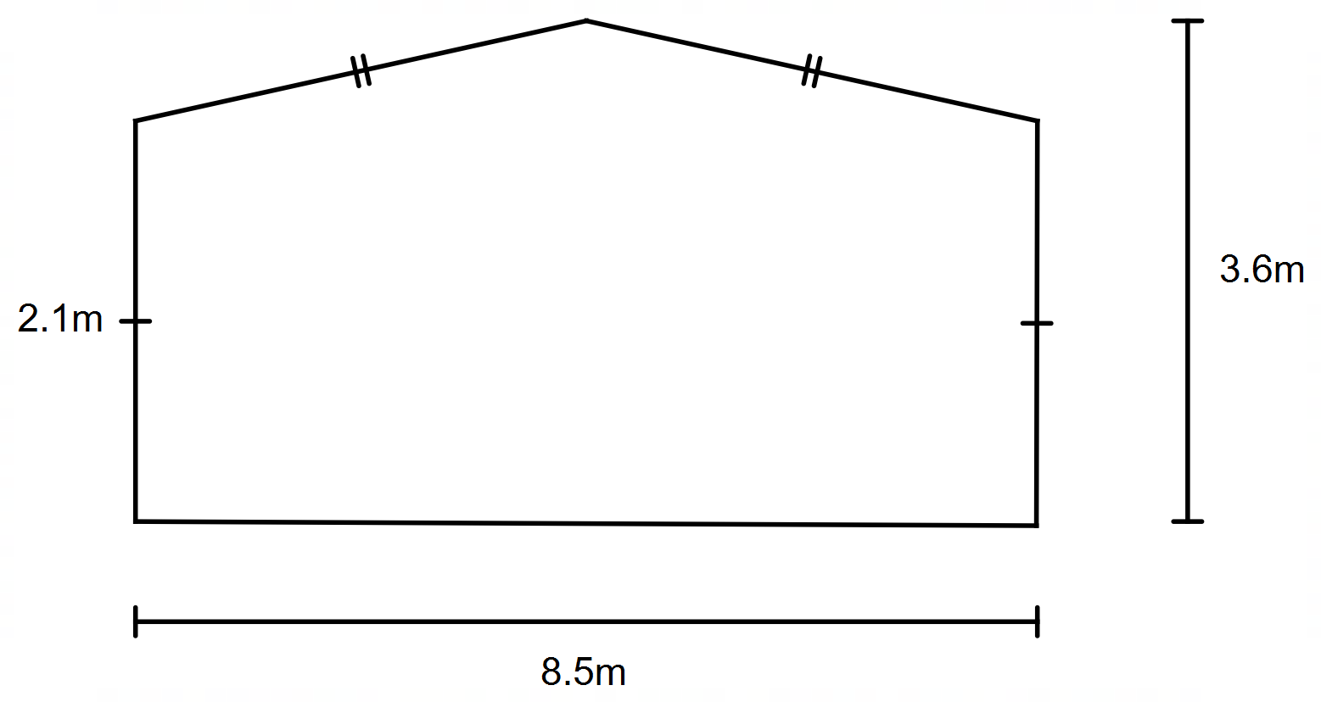

**Question 10 (4 marks)**

Garry won $20 000 in a lottery and wants to invest it for a number of years.

He has two options.

(a) The first option is a simple interest-bearing account that pays 4.35% p.a.

for the first 3 years and an extra 0.65% p.a. for every year thereafter.

If Garry decided to invest the money for 5 years determine the amount of

interest he would earn over the 5 years. (2 marks)

(b) The second option is to go to another bank and receive an interest rate

of 4.12% compounded monthly. Determine the amount of interest Garry

would receive if he invested the money for 5 years. (2 marks)

**Question 11 (6 marks)**

Oscar has a road bike with 622 millimetre diameter wheels.

(a) Determine (to the nearest centimetre) the length of rubber used for one tyre. (2 marks)

(b) Oscar went for a ride on the bike and the wheel completed 2250 revolutions.

Determine (to the nearest 100 metres) the distance he rode. (2 marks)

(c) If the bike was ridden five kilometres, determine the number of revolutions

made by the wheel. Round your answer to the nearest 100 revolutions. (2 marks)

**Question 12 (5 marks)**

Justin and Ben have been doing an exercise program. They recorded their BMI scores

at the beginning and end of the exercise program.

(a) Given the Body Mass Index formula is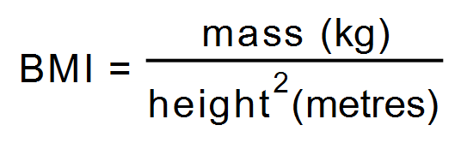, determine the

value of **A**, **B** and **C**. (3 marks)

|  |  |  |  |  |  |
| --- | --- | --- | --- | --- | --- |
|  | **Height** | **Start Mass** | **End Mass** | **Start BMI** | **End BMI** |
| **Justin** | 187cm | 87kg | **B** | **A** | 23.74 |
| **Ben** | **C** | 95kg | 89.5kg | 26.04 | 24.53 |

(b) Determine (to one decimal place) the percentage reduction in Ben’s BMI. (2 marks)

**Question 13 (4 marks)**

(a) Determine the simple interest percentage rate (p.a.) if an investment of

$1500 increases to $2238 after 6 years. (2 marks)

(b) In 2019, the annual inflation rate was 1.6% and Finn earned a salary of

$100 000 that year. If the annual inflation rate remains constant and Finn’s

salary keeps pace with inflation, determine Finn’s salary at the end of 2023. (2 marks)

**Question 14 (8 marks)**

Helen sees a dress advertised for $275 AUD plus GST on an Australian online

shopping website.

(a) Determine how much Helen will pay for the dress. (1 mark)

(b) Helen must pay postage and handling costs. These costs are based on

1.2% of the GST inclusive price.

Determine the total amount that Helen will pay for the dress. (2 marks)

Maria, Helen’s friend, sees a dress advertised on an overseas online

shopping website.

The price of her dress is advertised for 4138 THB (Thai Baht).

(c) (i) If $8 AUD is equivalent to 165.52 THB, determine the cost

(in Australian dollars) of Helen’s dress. (2 marks)

(ii) Maria had to pay $5 AUD for postage and handling. Determine this

amount in THB. (1 mark)

Another friend of the two girls, Pauline, bought a second-hand dress. She paid

$252 AUD for the dress and was told that that price was based on a 28% discount.

(d) Determine the original price of the dress. (2 marks)

**Question 15 (8 marks)**

(a) Sarah would like to give her friends a decorated white candle as a gift.

Cylindrical white candles are to be used and she is producing a label that will

wrap around the candle. If the label has an area of 226.2cm2 and a height

of 12cm, determine the diameter of the candle. (3 marks)

(b) At Joe’s Budget Hire Car Company, if a person hires a car for 7 or more days

they are charged a cheaper daily rate for the duration of the hire. The table below

shows the type of car, how many people it can hold and the different daily hire rates.

|  |  |  |  |
| --- | --- | --- | --- |
| **Type of Car** | **Number of people car holds** | **Daily Hire** | **7 or more days daily hire** |
| Small | 3 | $23 | $18 |
| Medium | 4 | $30 | $24 |
| Large | 5 | $36 | $31 |

Determine:

(i) The total cost to hire a small car for 3 days. (1 mark)

(ii) The total cost to hire a large car for 8 days. (1 mark)

(iii) The cheapest way to hire two cars that will together hold 8 people

for 2 days. (2 marks)

(iv) The cost to hire a medium car from the 18th to 24th June inclusive. (1 mark)

**Question 16(9 marks)**

Jasmine purchases 3000 shares in Company ABC at a price of 6.5 cents per share.

She must pay a brokerage fee of 8% of the purchase price.

(a) Determine the total cost in buying the shares. (2 marks)

After one-year, Jasmine was reviewing her share portfolio and decided to compare

the price to earnings ratio of Company ABC to Company XYZ.

(b) Determine the price to earnings ratio, to two decimal places, for Company ABC

if the market price was 9.6c per share and the annual earnings per share was

1.31 cents. (1 mark)

(c) If Company XYZ has a price to earnings ratio of 9.37, determine which

company Jasmine should invest in. Explain. (2 marks)

(d) Determine the market price for Company XYZ shares if the earnings per

share is $1.14. (2 marks)

(e) Use your answer from (d) and calculate the dividend yield, as a percentage,

(to two decimal places) for Company XYZ if the company paid an annual

dividend of 25 cents per share. (2 marks)

**Question 17 (16 marks)**

(a) Sam wants to brick pave his rectangular backyard. The dimensions of his

backyard are 24 metres by 12 metres. The paving brick he wants to use has

dimensions of 40 centimetres by 40 centimetres and are sold in packs of six.

Determine how many packs Sam will need to buy to pave his backyard. (4 marks)

(b) A birthday cake is made in the shape of a cone. When cooked, the cake

will be sliced in half (along the vertical line). Each half will be coated, all over,

with chocolate icing.

Determine the area to be covered to the nearest square centimetre. (4 marks)

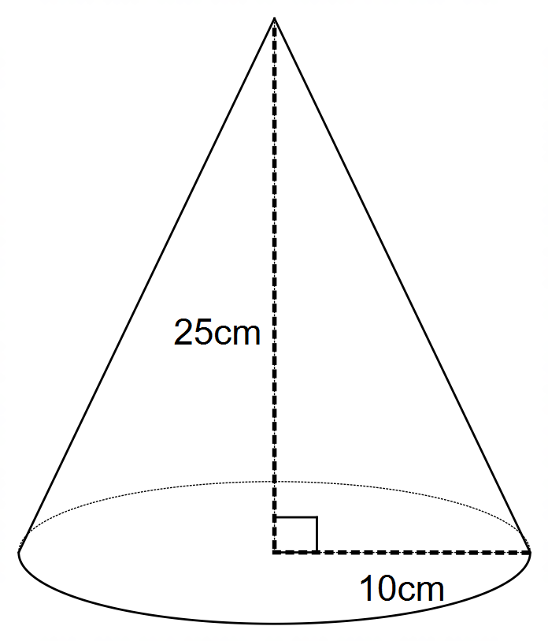

(c) A circular lid has a section cut from it as shown by the shaded section

in the diagram below. If the lid has a diameter of 16 centimetres determine

the remaining area. (3 marks)

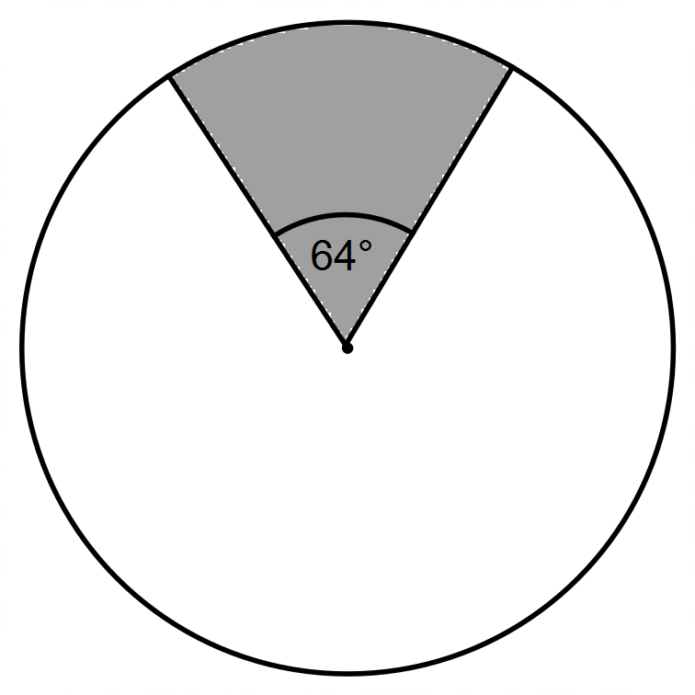

(d) The Year 11 students have made door stoppers, as shown below, for the

one hundred and twenty new Year 7 students coming to the school. The

Year 7 students are to apply two coats of paint to the door stopper. The

paint to be used can only be purchased in 200mL tins and each tin covers

an area of 0.85m2.

Determine whether six tins of the paint will be enough to complete the task.

**Full working out must be shown for full marks to be awarded.** (5 marks)

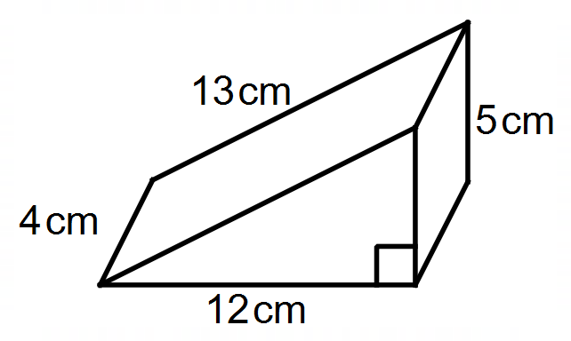

**Question 18 (6 marks)**

The Letterbox Drop Company employs people to deliver three types of advertising material.

The table below represents the amount of money paid per item delivered. If you deliver

between 1 and 1000 items you are paid a rate for that number. If you deliver over 1000 you

are paid a higher rate for the number of items over the 1000. The rate continues to increase

the more you deliver.

|  |  |  |  |
| --- | --- | --- | --- |
| Number delivered | Single page flyer | Shopping brochure | Magazine |
| 0 - 1000 | 2c | 3c | 20c |
| 1001 - 2000 | 3c | 4c | 30c |
| 2001 - 3000 | 5c | 8c | 40c |
| 3001 + | 10c | 12c | 50c |

(a) In one week, Michael delivered 1800 Single page flyers, 1000 Shopping

brochures and 2100 Magazines. Calculate the amount of money he earned. (4 marks)

(b) Use a trial and error approach, or otherwise, to determine how many shopping

brochures Michael delivered if he earned $122 for the week. (2 marks)

**Question 19 (3 marks)**

The diagram below represents a net of a square based pyramid with a square

base area of 25cm2. Determine the volume of the three-dimensional figure. (3 marks)

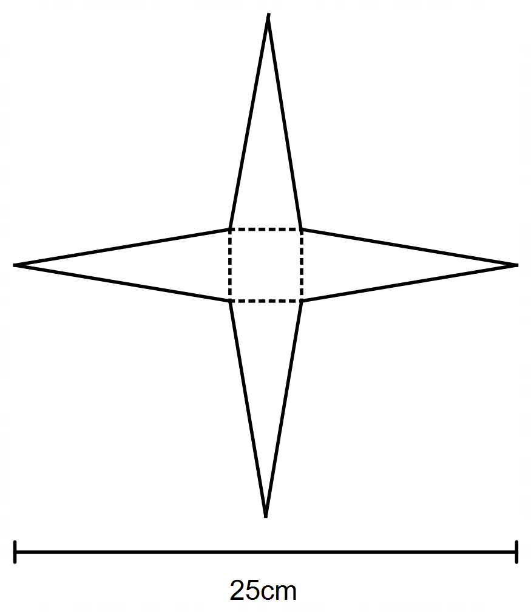

**Question 20 (6 marks)**

Jim works five days per week and is paid weekly. Each week he sets aside money

to budget for the following expenses he incurs throughout the year.

3 Monthly Gas bill for $200 2 Monthly Power bill for $450

Monthly Mobile Phone bill for $70 Weekly Rent for $420

Daily Parking for $8

(a) Determine the amount he sets aside per week to cover his expenses. (4 marks)

(b) After Jim has set aside the money for his expenses, he has 35% left of his pay.

Determine Jim’s weekly wage. (2 marks)

**Question 21 (8 marks)**

Worldly Chocolate Company produces spherical shaped chocolates. Each chocolate

has a two-centimetre diameter centre of white chocolate covered with a two-millimetre

thick dark chocolate coating.

(a) Determine the volume of white chocolate used to one decimal place. (2 marks)

(b) Show, to the nearest cm3, that 3cm3 of dark chocolate is used for the outside coating. (2 marks)

(c) Chocolates are sold in a box of twelve. The cardboard box has a mass of

forty-five grams. If one gram of chocolate is equivalent to one cubic centimetre

determine the total weight of a box of chocolates. (2 marks)

(d) If the chocolate in the box was melted, and was formed into a cube,

determine the side length of the cube, to one decimal place. (2 marks)

**Question 22 (7 marks)**

The school canteen supplies three different types of milk to the staffroom. Milk is

delivered to the staffroom three times a week (Monday, Wednesday and Friday)

and the quantity and type delivered per day is shown in the table below.

The cost per container type are: Full cream ($2.20), Hi Lo ($2.30) and Skim ($2.40).

|  |  |  |  |
| --- | --- | --- | --- |
| **Day/Type** | **Full Cream** | **Hi Lo** | **Skim** |
| **Monday** | 4 | 2 | 1 |
| **Wednesday** | 3 | 2 | 1 |
| **Friday** | 2 | 2 | 1 |

(a) Represent the information in the table in a 3 x 3 matrix, **S.** (1 mark)

(b) Represent the cost per container type of milk in a 3 x 1 matrix, **C.** (1 mark)

(c) Represent the total cost of each type of milk supplied in a matrix, **T**,

and hence, determine the total cost for the week. (2 marks)

(d) The canteen needs to mark up the prices and charge the school.

The canteen manager marks up all prices by 22%.

(i) Represent the result of this in a matrix, **M**. (2 marks)

(ii) Determine the profit the canteen makes each week (**M** – **T**). (1 mark)

**End of questions**

**Additional working space**

Question number(s): …………….……

WATP acknowledges the permission of the School Curriculum and Assessment Authority in providing instructions to students.